*Tableau Dashboard Documentation Anh Quan Hua*

# 1. Introduction

*Definitions*: Tableau Dashboards are compact views consisting of many different visualizations that aim to help users to quickly grasp the main insights to be showcased. Since the analysis report contains visualizations that might not be easily interpret to a wide range of viewers, our Tableau Dashboards are created to highlight different answers to frequently asked topics.

*Implementation*: With how our datasets are structured, it is crucial to clean the data to remove null and misleading data before using it. In this documentation, we will provide in-depth details to the formation of the Dashboards.

*Data sources:* Fitness Track Products E-commerce:

<https://www.kaggle.com/datasets/devsubhash/fitness-trackers-products-ecommerce>

# 2. Dashboard

## a. Top Competitors Overview Dashboard

**Aim of the dashboard:**

This dashboard aims to provide clear insights to how the top company are being received in a particular market. It answers questions such as: What is the average selling price for each of the brands, how much coverage are each company getting and what is the average ratings for the top sellers.

**Link to the public dashboard:**

<https://public.tableau.com/app/profile/quan.h5693/viz/FitnessWearablesWorkbook/TopBrandsDash>

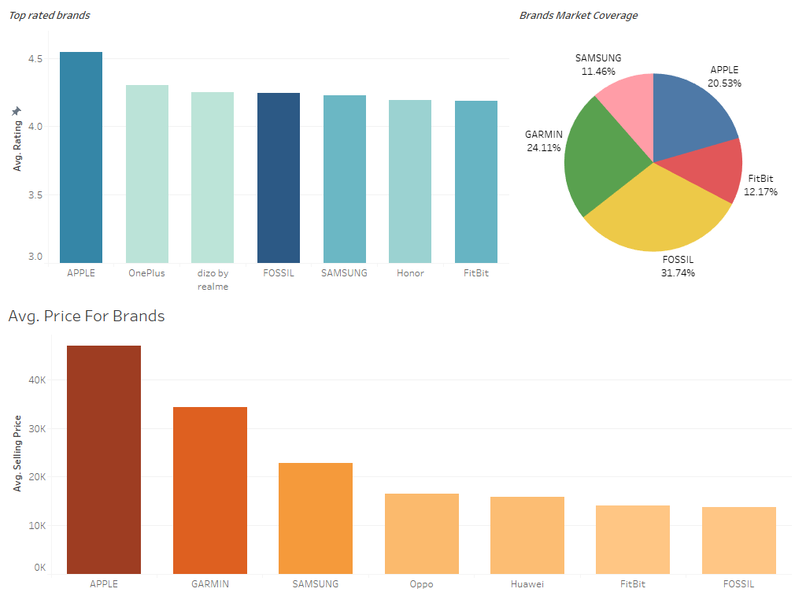

**Data used:**

<https://www.kaggle.com/datasets/devsubhash/fitness-trackers-products-ecommerce>

**Data Pre-processing:**

After view the data, we would want to first convert the type for our ‘Selling Price’ and ‘Original Price’ to numeric as the Pandas library in Python was not recognizing the correct type. This may be unnecessary as Tableau still interprets these columns as measurements.

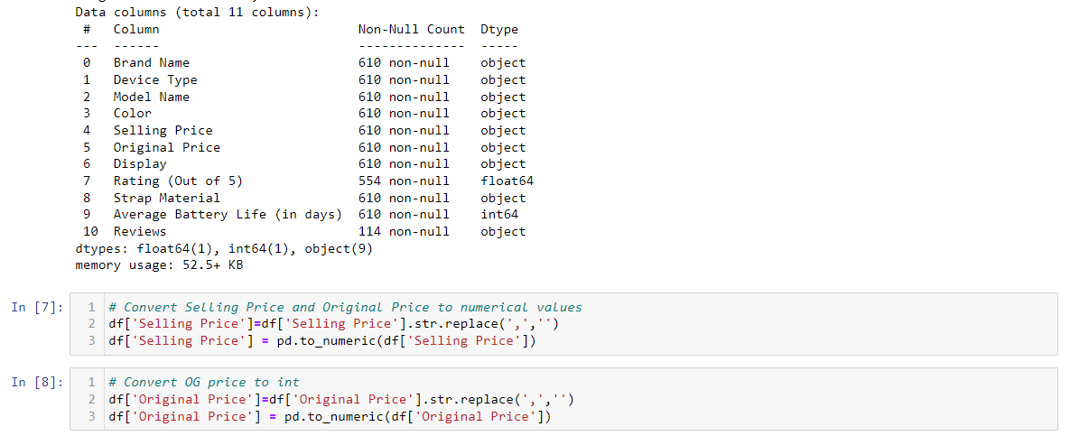

Next, we are going to rename two columns to keep our labeling clear, as well as dropping the ‘Reviews’ columns as it contains too many missing values.

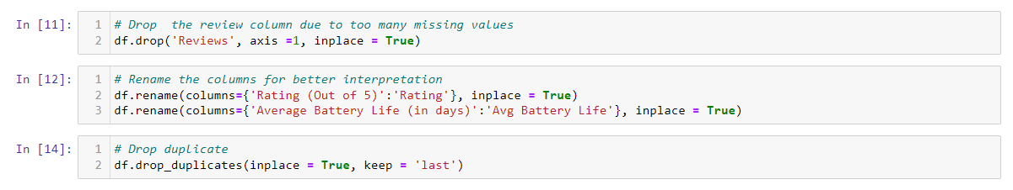

Finally, we impute the missing data in the remaining 55 spots from ‘Ratings’ column and export our newly cleaned CSV file.

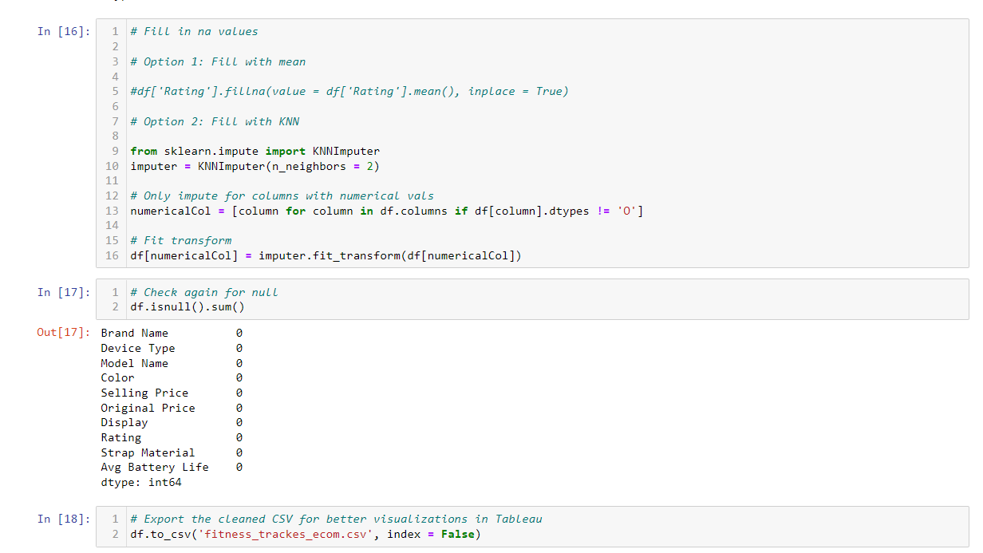

**Graph Details:**

*1st Graph:*

This graph details the average ratings of the top 7 brands. As we can observe, Apple is trailing ahead in this market with nearly 4.6 average rating for their products. Others such as Oneplus, dizo, Fossil or Samsung are also doing very well ratings wise.

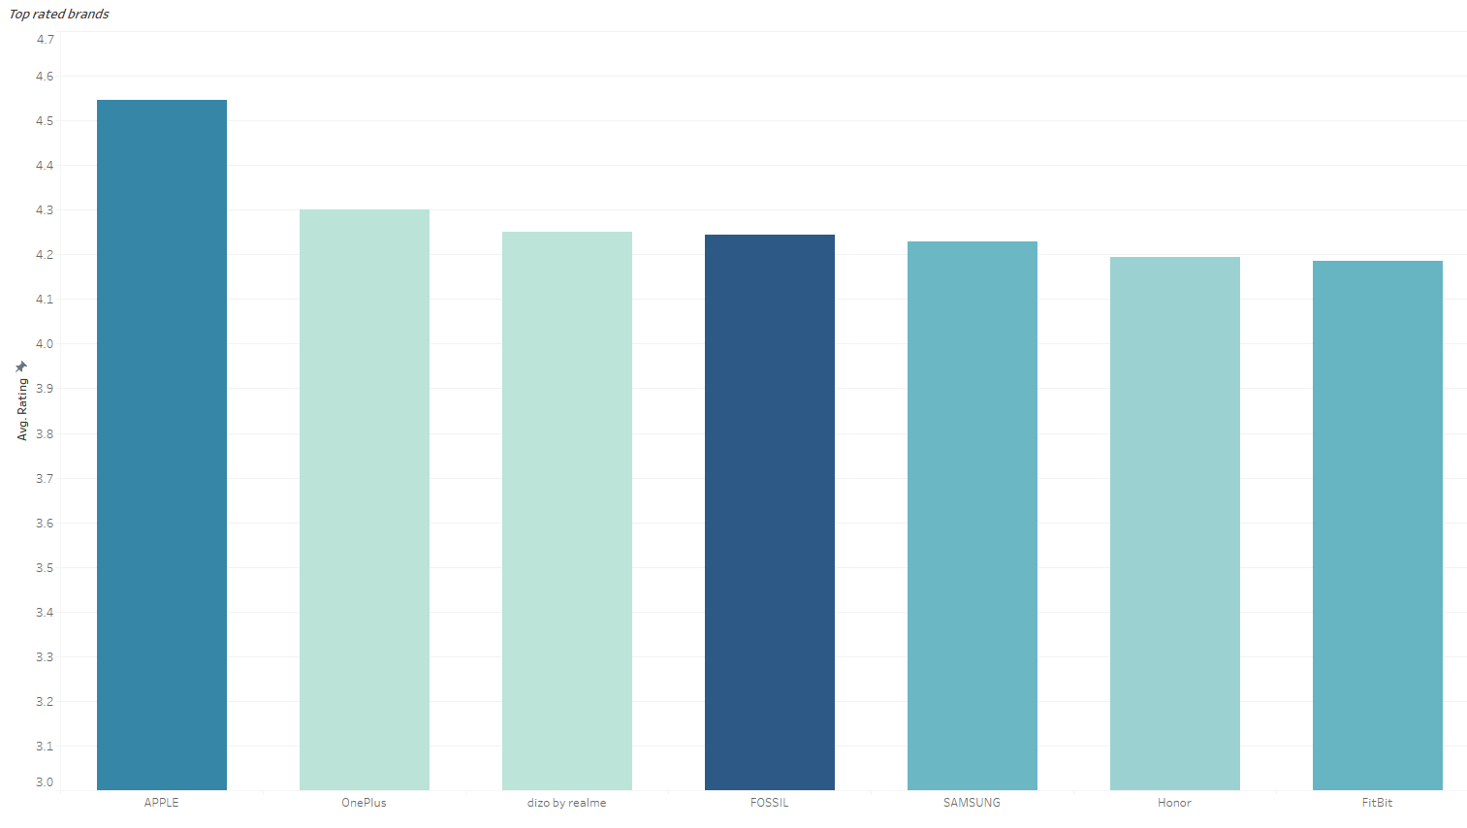

*2nd Graph:*

This graph shows the highest average selling price per device for different brands. From this, we can see that while producing the best rated products, Apple is also the clear leader in terms of selling prices, indicating it’s overwhelming presence in the high-end range. Other competitors such as Garmin and Samsung are not targeting the same price range but rather focus on the mid-tier wearables.

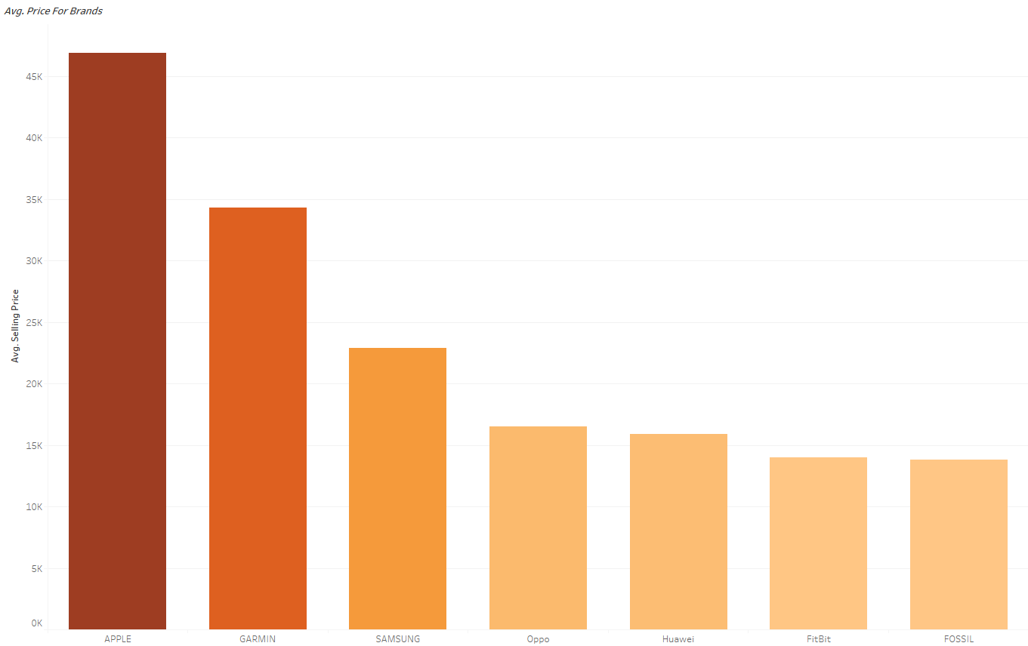

*3rd Graph:*

Finally, we have the graph that shows the market coverage for the top 5 brands. For this particular pie chart, the numbers from the rest of the companies were deemed to be insignificant as their numbers were far quite a bit lower from the top 5. Hence, the percentages might not be the most accurate but it is representative of the overall coverage that these brands have.

